ZOO DATABASE SYSTEM – ORACLE

USER REQUIREMENTS
In a zoo management system, various entities work together to ensure the efficient handling of animals. The Animal entity holds key details such as animal ID, species, name, gender, date of birth, current health status, diet, and arrival date at the zoo. Each animal is housed in a specific Habitat, which includes habitat ID, habitat type (e.g., savannah, rainforest), size, climate, maximum capacity, and status. A habitat can house one or many animals, depending on the species' requirements and behavior. However, a habitat may house no animals if it is under maintenance, undergoing renovations, or specifically designated for a species not currently present in the zoo, ensuring that the habitat is not overcrowded or unsuitable for the animals. Each habitat can accommodate a maximum of 30 animals to ensure adequate space and proper living conditions.

The Zookeeper entity stores the zookeeper ID, name, experience level, assigned habitat, and specialized skill (e.g., working with reptiles or large mammals). Zookeepers are assigned to care for one or more animals, and each animal is cared for by one or multiple zookeepers. The relationship includes attributes such as the date the zookeeper was assigned to the animal and the specific duties, they are responsible for, such as feeding, training, or health monitoring. Each zookeeper can supervise one, none, or more other zookeepers, while a zookeeper may also report to one supervisor. This relationship is characterized by attributes such as supervision start date, supervision end date, and supervision level.

A zookeeper may manage one or no zoo vehicle, with each vehicle assigned to a specific zookeeper; in some cases, a vehicle may not be managed by any zookeeper, such as during maintenance or if the vehicle is temporarily out of service. Each zookeeper is permitted to manage only one vehicle to ensure efficient allocation of resources and prevent the overextension of responsibilities. This limitation helps maintain accountability and ensures that vehicles are properly maintained and available for their designated duties within the zoo. The vehicle entity includes attributes such as vehicle ID, model, status, and plate number.

ENTITY RELATIONSHIP DIAGRAM (ERD)

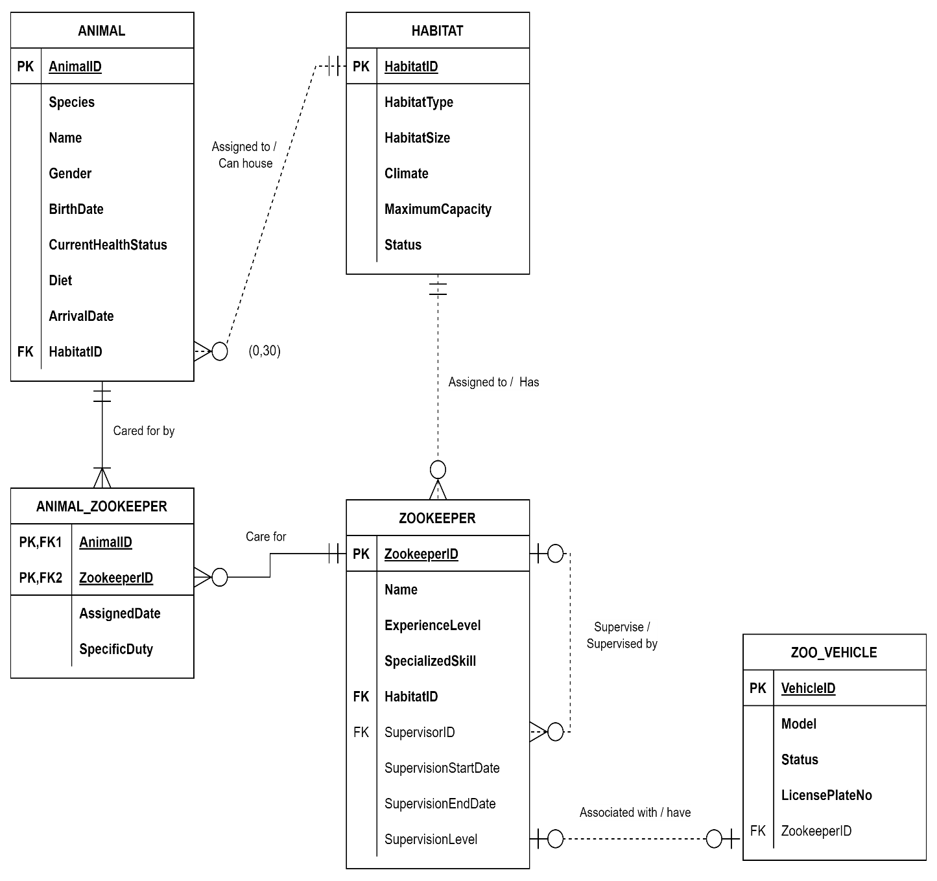

TABLE DATA
HABITAT table
HABITATID | HABITATTYPE | HABITATSIZE | CLIMATE | MAXIMUMCAPACITY | STATUS
H001 | Savannah | 1000 | Dry | 30 | Operational
H002 | Rainforest | 800 | Humid | 30 | Under Renovation
H003 | Arctic | 500 | Cold | 10 | Operational
H004 | Desert | 1200 | Hot | 30 | Designated for Future Use
H005 | Grassland | 900 | Temperate | 20 | Operational
H006 | Wetlands | 700 | Humid | 15 | Operational
H007 | Tropical Forest | 1100 | Humid | 25 | Operational
H008 | Tundra | 600 | Cold | 20 | Under Maintenance

ANIMAL table
ANIMALID | SPECIES | NAME | GENDER | BIRTHDATE | CURRENT  HEALTHSTATUS | DIET | ARRIVALDATE | HABITATID
A001 | Lion | Simba | Male | 14-AUG-15 | Healthy | Carnivore | 10-FEB-16 | H001
A002 | Elephant | Dumbo | Male | 21-MAY-13 | Injured | Herbivore | 05-NOV-14 | H005
A003 | Giraffe | Melman | Male | 09-JUL-18 | Healthy | Herbivore | 12-MAR-19 | H005
A004 | Penguin | Skipper | Female | 23-JAN-20 | Healthy | Carnivore | 08-JUN-20 | H003
A005 | Tiger | Shere Khan | Male | 25-JUN-14 | Healthy | Carnivore | 15-SEP-15 | H001
A006 | Zebra | Marty | Male | 16-APR-17 | Healthy | Herbivore | 18-FEB-18 | H005
A007 | Kangaroo | Roo | Female | 30-NOV-19 | Healthy | Herbivore | 10-MAR-20 | H007

ZOOKEEPER table
ZOOKEEPER  ID | NAME | EXPERIENCE  LEVEL | SPECIALISED  SKILL | HABITAT  ID | SUPERVISOR  ID | SUPERVISION STARTDATE | SUPERVISION ENDDATE | SUPERVISION  LEVEL
ZK001 | John Smith | Expert | Large Mammals | H001 | - | 15-JAN-20 | - | 1
ZK002 | Alice Brown | Intermediate | Reptiles | H002 | ZK001 | 10-MAR-21 | - | 2
ZK003 | Mike Green | Beginner | Birds | H003 | ZK002 | 05-JUN-22 | - | 3
ZK004 | Sarah Jones | Expert | Small Mammals | H004 | - | 20-FEB-20 | - | 1
ZK005 | Rachel Lee | Intermediate | Herbivores | H005 | ZK004 | 10-APR-21 | - | 2
ZK006 | Mark Black | Beginner | Amphibians | H006 | ZK005 | 01-JUL-22 | - | 3
ZK007 | Peter White | Advanced | Large Carnivores | H007 | ZK001 | 15-SEP-20 | - | 2
ZK008 | Laura Grant | Intermediate | Polar Animals | H008 | ZK004 | 20-MAY-21 | - | 2

ANIMAL_ ZOOKEEPER table
ANIMALID | ZOOKEEPERID | ASSIGNEDDATE | SPECIFICDUTY
A001 | ZK001 | 15-JAN-17 | Feeding, Training
A002 | ZK001 | 10-MAR-16 | Health Monitoring, Feeding
A003 | ZK002 | 01-APR-19 | Health Monitoring, Feeding
A004 | ZK003 | 10-JUL-20 | Feeding, Health Monitoring
A005 | ZK007 | 05-OCT-16 | Feeding, Training
A006 | ZK005 | 05-MAR-18 | Training, Feeding
A007 | ZK003 | 15-APR-20 | Feeding, Enrichment Activities

ZOO_VEHICLE table
VEHICLEID | MODEL | STATUS | LICENSEPLATENUMBER | ZOOKEEPERID
V001 | Toyota Hilux | Operational | XYZ1234 | ZK001
V002 | Ford Ranger | Under Maintenance | ABC5678 | -
V003 | Honda CR-V | Operational | DEF9012 | ZK002
V004 | Jeep Wrangler | Operational | GHI3456 | ZK003
V005 | Land Rover | Under Maintenance | JKL6789 | -
V006 | Ford Escape | Operational | MNO1234 | ZK004

